1. **System defined variables.**

#env: command to check system defined variables in current shell.

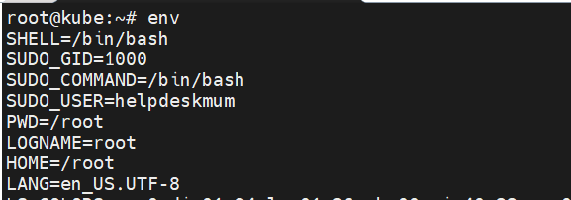

Examples of system defined variables.

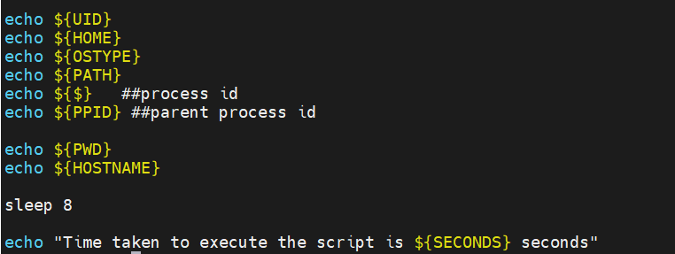

1. **Reading input and printing the output.**

-p: this flag is used to print message and define variable name in same line.

-s: this flag is used to hide the input which you are entering.

echo with blank: It is used to display output on next line after hidden input entered by user i.e. password.

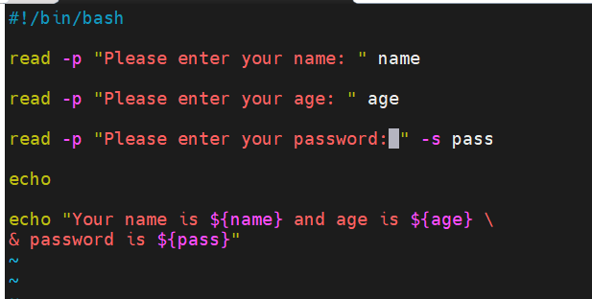

1. **Command line argument**

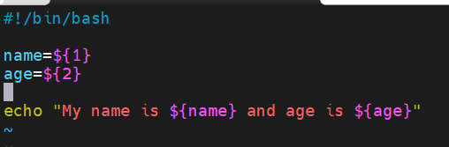

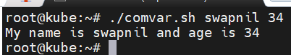

Note: Never use/put space while defining variables else it will be consider as a command.

1. **Storing linux command value in variable.**

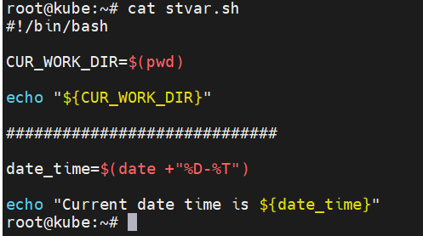

1. **Making read-only variable.**

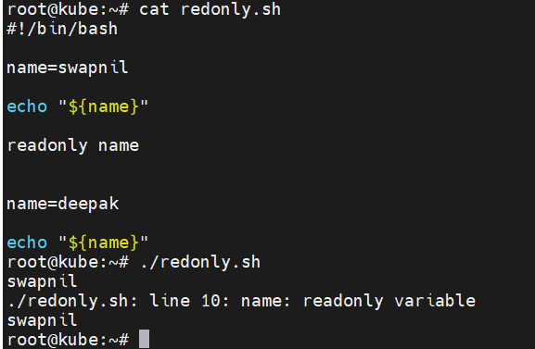

1. **Unset the variables.**

